# **What is Generative AI?**

* Generative AI is the most recent advancement in the field of **machine learning**
* Generative AI technologies are **capable of creating new content**, ranging from text to images and video
* The most popular generative AI technologies are called **Large Language Models**, or LLMs for short

# **Gen AI and the Hype Cycle**

According to Gartner’s***Hype Cycle for Emerging Technologies***from August 2023, generative AI is at its peak of inflated expectations.

* Along with the hype comes a lot of empty promises and predictions. Now is the time to begin unpacking how this technology can and will impact TAG’s industry.

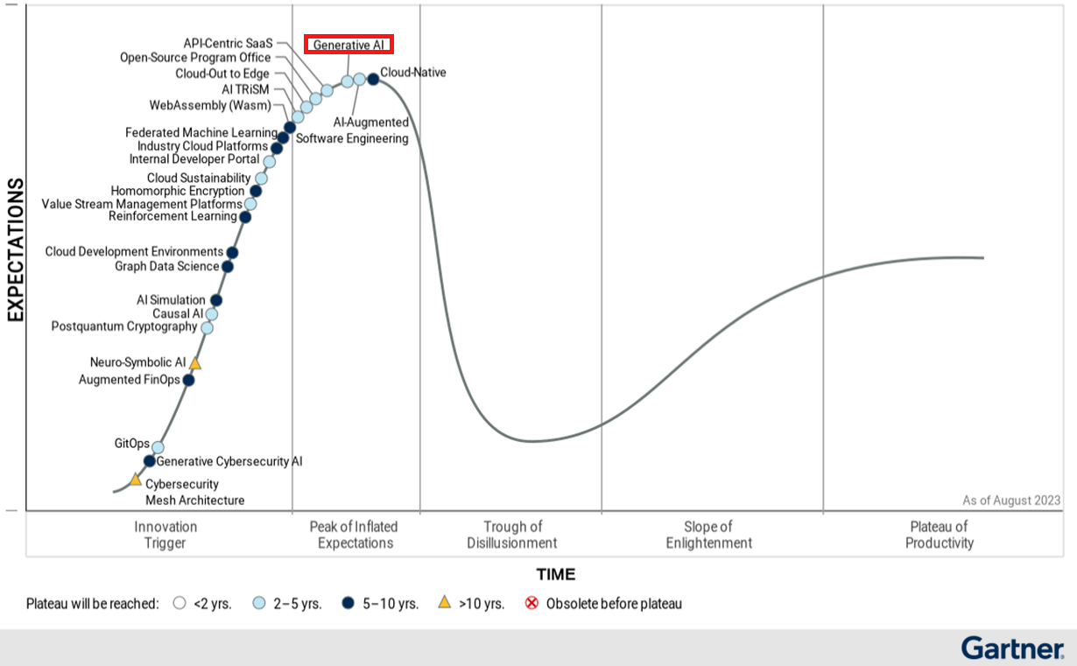

*Source:* [*Gartner August 2023*](https://www.gartner.com/en/newsroom/press-releases/2023-08-16-gartner-places-generative-ai-on-the-peak-of-inflated-expectations-on-the-2023-hype-cycle-for-emerging-technologies#:~:text=Figure%201.%20Hype%20Cycle%20for%20Emerging%20Technologies%2C%202023)

# **How Do They Work?**

| **1**  The LLM receives an **input** from the user via a prompt. | ➡ | **2**  The LLM **decodes**, or “reads,” the prompt. | ➡ | **3**  The LLM puts together a response by making **predictions** based on its training data. |
| --- | --- | --- | --- | --- |

# **Who is Paving the Way in the Generative AI Space?**

### **Proprietary** Models:

|  |  |  |  |  |
| --- | --- | --- | --- | --- |
| OpenAI’s **GPT-4 Turbo** was released in 2023, and is still the top performing model in the space. |  | Google is releasing **Gemini** and **Gemini Ultra** in 2024. They claim it is an upgrade to GPT-4. |  | **Microsoft Copilot** was released at the end of 2023, and runs on OpenAI’s GPT-4 model. Microsoft also controls a seat on OpenAI’s board. |

### **Open Source** Models:

|  |  |  |  |  |
| --- | --- | --- | --- | --- |
| In addition to its emphasis on safety and responsible use, Meta’s **LLaMA 2** has outperformed many models on reasoning and coding benchmarks. |  | TII’s **Falcon LLM** is one of the largest open source models and has outperformed GPT-3 on various benchmarks. |  | BigScience’s **BLOOM LLM** is a collaborative, global effort. BLOOM is trained on 46 languages, making it possibly the most diverse model to date. |

*Source:* [*Creole Studios*](https://www.creolestudios.com/top-5-open-source-llm/)

# **What Legislation is Impacting AI in 2024?**

### The European Union’s **AI Act:**

* Safeguards agreed on general purpose artificial intelligence
* Limitation for the of use biometric identification systems by law enforcement
* Bans on social scoring and AI used to manipulate or exploit user vulnerabilities
* Right of consumers to launch complaints and receive meaningful explanations
* Fines ranging from 35 million euro or 7% of global turnover to 7.5 million or 1.5% of turnover

*Source:* [*European Parliament, 2023*](https://www.europarl.europa.eu/news/en/press-room/20231206IPR15699/artificial-intelligence-act-deal-on-comprehensive-rules-for-trustworthy-ai)

### **Copyright** Issues Impacting the Space

* LLMs and AI Art Generation models have come under scrutiny for using content to train the models without the content creators’ permission
* Copyright laws are not yet equipped to handle the legality of using web content to train these AI models
* Several notable lawsuits have been filed against OpenAI, including from the New York Times and comedian Sarah Silverman